FURI Proposal
Hoppers are used in industrial applications, such as ore processing and pharmaceutical manufacturing, to dispense materials at a uniform rate to a given process. The material that a hopper dispenses usually come in the form of particles of different sizes, shapes and surface roughness’s. Understanding the interactions between these particles is key for the prediction of their behavior in these industrial applications. With these behaviors known, constant and efficient processes can be devised that will lead to a product that is produced with the same consistency and quality, time and again. This will in turn lead to less waste in terms of bad batches and time spent trying to save inconsistent batches thus making process’s involving hoppers more streamline and sustainable.
The purpose of this FURI is to investigate the effect that surface roughness, induced by base etching, has on the flow rate of glass beads of different sizes in a hopper. The differences in flow rates of the beads will give insight into the particle-particle interactions that is not only relevant to hopper discharge characterization but also to fluidized beds, and floatation recovery of ores^{1,2}. These particle-particle interactions include friction induced by the particles moving past each other, cohesive forces between the particles, and the packing of the particles. All these interactions are effected by the roughness of the particle especially the cohesive forces².
Hassas et al. used HF to roughen the glass beads used for their experiments¹. We will be using sodium hydroxide to produce glass beads of different roughness. Not only is this safer but base etching in a common way to etch silicon wafer, which leads us to conclude that it is an industrially practical way to etch glass³. Also, we are not the first to use sodium hydroxide as a glass etchant. Zhang et al. used sodium hydroxide to etch silica beads that were coated in a protective layer in order to hollow out the beads⁴. The glass beads will be exposed to different concentrations of sodium hydroxide, ranging from 4M – 12M solutions while being stirred in beaker at room temperature. The 12M solution will likely give the glass beads a smooth finish while the lower molar concentrations will likely give more of a rough finish due to slower etching rates^{3,5}. To quantitively characterize the roughness of the glass beads, atomic force microscopy (AFM) can be used following the techniques described in Hassas et al to measure the roughness of a small sphere¹.
The following experimental procedure will be followed, to find the effect different roughness’s and sizes, have on the flow rate of the glass beads through a small hopper. 500 grams of glass beads will be weighed out and put into the hopper set up. Below the hopper will be a tared beaker on a scale that will record the weight at specified time intervals as the beads flow from the hopper into the beaker and upload the data to MS Excel. With the data, a weight vs time graph will be made in MS Excel. Each run will be done in triplicate. Using different roughness’s and varying glass bead sizes, we hope to find the general trend in the flow rates and correlate it to the different surface roughness’s and size of the beads.
Following the Fulton School of Engineering’s theme of sustainability this FURI project aims to make chemical engineering processes involving hoppers more efficient. This is done through furthering the understanding of particle-particle interactions and their contribution to particle flow. This understanding can then be applied to different chemical processes, making them more sustainable due to less bad batches and time lost fixing inconsistent batches. This project also uses less hazardous chemicals for etching which will lead to not having to dispose of harmful waste.

Bibliography
1. Vaziri Hassas B, Caliskan H, Guven O, Karakas F, Cinar M, Celik MS. Effect of roughness and shape factor on flotation characteristics of glass beads. Colloids Surfaces A Physicochem Eng Asp. 2016;492:88-99. doi:10.1016/j.colsurfa.2015.12.025
2. LaMarche CQ, Liu P, Kellogg KM, Hrenya CM. Fluidized-bed measurements of carefully-characterized, mildly-cohesive (Group A) particles. Chem Eng J. 2017;310:259-271. doi:10.1016/j.cej.2016.10.119
3. Situation TC, Technology U, Crystals SS. The Current Situation in Ultra-Precision Technology À Silicon Single Crystals as an Example.; 2012. doi:10.1016/B978-1-4377-7859-5.00003-X
4. Zhang Q, Zhang T, Ge J, Yin Y. Permeable Silica Shell through Surface-Protected Etching. Nano Lett. 2008;8(9):2867-2871. doi:10.1021/nl8016187
5. Eske LD, Galipeau DW. Characterization of SiO2 surface treatments using AFM, contact angles and a novel dewpoint technique. Colloids Surfaces A Physicochem Eng Asp. 1999;154(1-2):33-51. doi:10.1016/S0927-7757(98)00907-8

Timetable
Fall 2018
October | Become accustomed and knowledgeable of equipment and key principles of project. Order necessary equipment and chemicals.
September | Begin base etching of beads, varying the base concentration and etching duration. Start running experiments and collect data.
November | Run experiments and collect data. Analyze results.
Spring 2019
January | Review literature, etch more glass beads at different concentrations and durations to get a better over view of the effect roughness has on the flowability of the particles.
February | Run experiments. Prepare FURI poster.
March | Run experiments. Prepare FURI poster and begin final report.
April | Analyze final data. Finish FURI poster and final report.

Personal Statement
Chemical engineering is a means to creating a more sustainable world. This is my view on chemical engineering, that motivates me to pursue this degree. I believe that chemical engineers can make a huge impact on the world by creating more efficient industrial processes and by adhering to ethical practices while preforming existing chemical processes. My personal goal is to apply my view of chemical engineering in the pharmaceutical industry, which I plan to work in one day. I want to strive to make processes more efficient, thus making the product cheaper and the production less harmful to the environment.
This research project aligns well with my personal goals because of the extensive use of particles and granules in pharmaceutical processes. Researching how particles interact with each other and their surroundings will streamline current processes and open the door for the development of new processes. Also, with this research I will be able to show future employers that I have an in-depth understanding of many processes and principles associated with pharmaceutical production.
Doing a FURI project has always been a goal of mine when I transferred to ASU. I was first exposed to FURI when the engineering club at Mesa Community College was invited to attend the FURI symposium in Spring 2016. It was amazing seeing all the undergraduate students who participated and showed me first hand that research is not out of reach of undergraduate students.

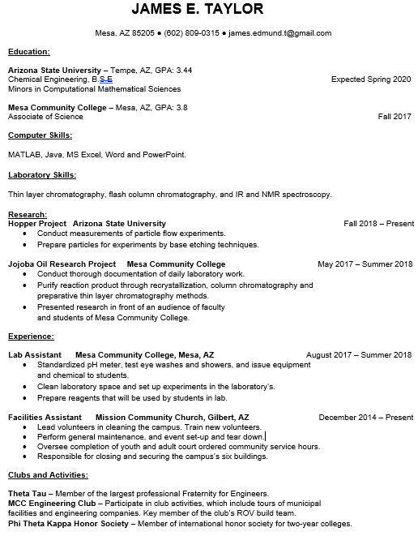

Unofficial Transcripts
